3.4 Position-Velocity-Acceleration AP Calculus AB Name_______________________

Click on this link or open up a browser and go to this URL. https://www.geogebra.org/m/qvK7r9Q2 The screen on your browser should similar to the picture below.

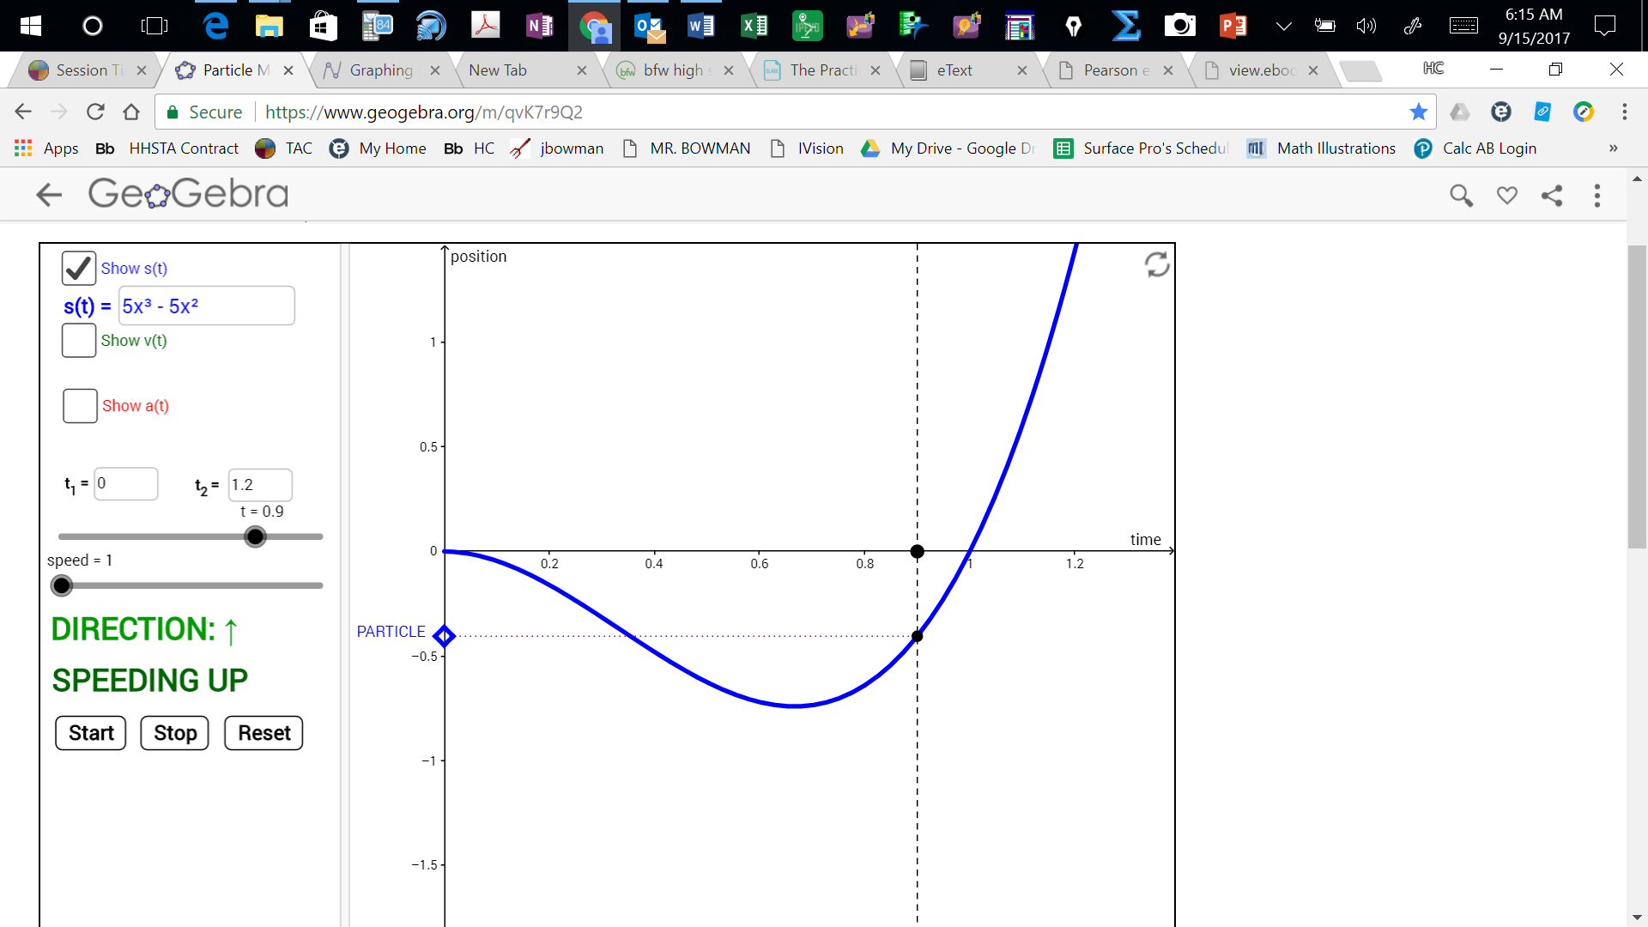

First, note that there is an incosistency in the function notation. This page shows 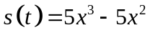
Clearly this is incorrect use of function notation as a function of t should not depend on x. Anyway, lets assume that x is really time and therefore actually is a function of t.

On the middle left of the screen, set the speed to 1 and click . You will notice the PARTICLE moving down (negative direction) and eventually up (positive direction) along the y-axis. You will also notice the DIRECTION the particle is moving being indicated on the left side of the screen with a green up arrow (positive direction) or down with a red down arrow 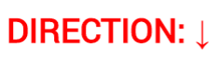 (negative direction). In addition, you will also see whether the particle is or 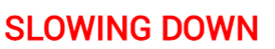. To replay the motion of the particle click then click . To control the movement of the particle yourself, click and hold the time slider as you move it back and forth or put the pointer on either side of the dot representing time and click to get the time to change in that direction.

- Over what time interval is the particle in a negative position? Use interval notation.

- What is true about the graph of position 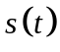 when the particle is in a negative position?

- Over what time interval is the particle in a positive position? Use interval notation.

- What is true about the graph of position when the particle is in a positive position?

- Over what time interval is the particle moving in a positive direction? Use interval notation.

- What is true about the graph of position when the particle is moving in a positive direction?

- Over what time interval is the particle moving in a negative direction? Use interval notation.

- What is true about the graph of the position when the particle is moving in a negative direction?

Now click on the box to the left of “Show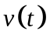”. You will see that this is the derivative 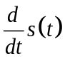of . will be graphed in green on the screen.

- Using the graph of , what is sign of the velocity when the particle is moving in a positive direction?

- Using the graph of , what is sign of the velocity when the particle is moving in a negative direction?

- The velocity of the particle is the rate of change of the position of the particle. Explain why it make sense that is positive when the particle is moving in a positive direction.

- Explain why it make sense that is negative when the particle is moving in a negative direction.

Now click on the box to the left of “Show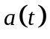”. You will see that this is the derivative of and the second derivative of 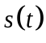. In other words 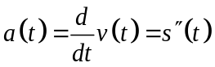. You will seegraphed in red on the screen.

- Using the graph of , what is happening to the velocity of the particle when the acceleration of changes sign?

- Explain why it make sense that is negative when the particles velocity is decreasing?

- Explain why it make sense that is positive when the particles velocity is increasing?

- Now find the intervals of time which the particle is speeding up. Use interval notation.

- What is the relationship between and when the particle is speeding up?

- Now find the interval of time which the particle is slowing down.

- What is the relationship between and when the particle is slowing down?

SUMMARY OF WHAT YOU HAVE FOUND

is the position of a particle at time t.
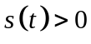 when the particle is in a positive position (above or to the right of zero).
When is increasing, the particle moving in a positive direction (up or right).
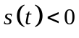 when the particle is in a negative position (below or to the left of zero).
When is decreasing, the particle moving in a negative direction (down or left).

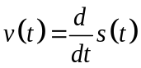 is the velocity of the particle at time t.
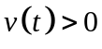 when the particle is moving in the positive (up or right) direction.
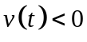 when the particle is moving in the negative (down or left) direction.

is the acceleration of a particle at time t.
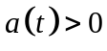 when the velocity of the particle is increasing.
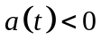 when the velocity of the particle is decreasing.

A particle is speeding up when 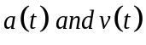have the same sign.
A particle is slowing down when have opposite signs.

